**3S 10A Battery Management System (BMS)**

This module is known as BMS for 11.1v Battery. This module protects the battery for short circuit, overcharge, over discharge and overcurrent. It is a cheap or low-cost module and very affordable and it charges each cell of battery pack in equal manner. But remember there is a difference between balance charging and equal manner. Balance charging is that the module with this feature Charges the battery equal like all cell will have voltage and if voltage of one cell cross the voltage of other cells, then the battery with higher voltage will get discharge through a resistor connected.

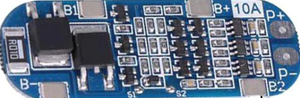

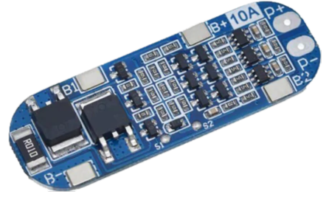

**Protection Features of 3S 10A BMS Circuit Diagram**

A BMS is essential for extending the service life of a battery and also for keeping the battery pack safe from any potential hazard. The protection features available in the 3s 10A Battery Management System are:

* Overvoltage protection
* Short circuit protection
* Undervoltage protection
* Decayed self-recovery

**BMS connection with Battery pack**

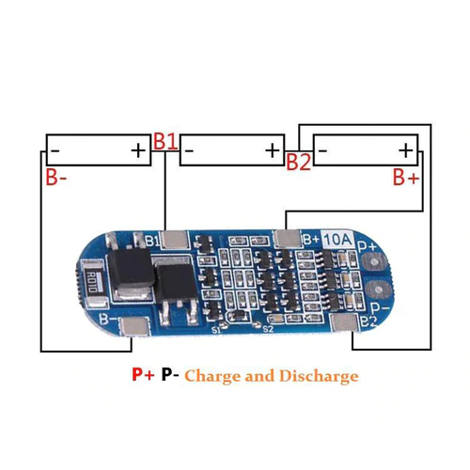

In this BMS we see on top there are some solder spots at the edge of the module and are labelled as B-, B1, B2, B+, P+, P- and under the module u can see 0v, 3.7v, 7.4v, 11.1v, P+, P- as shown.

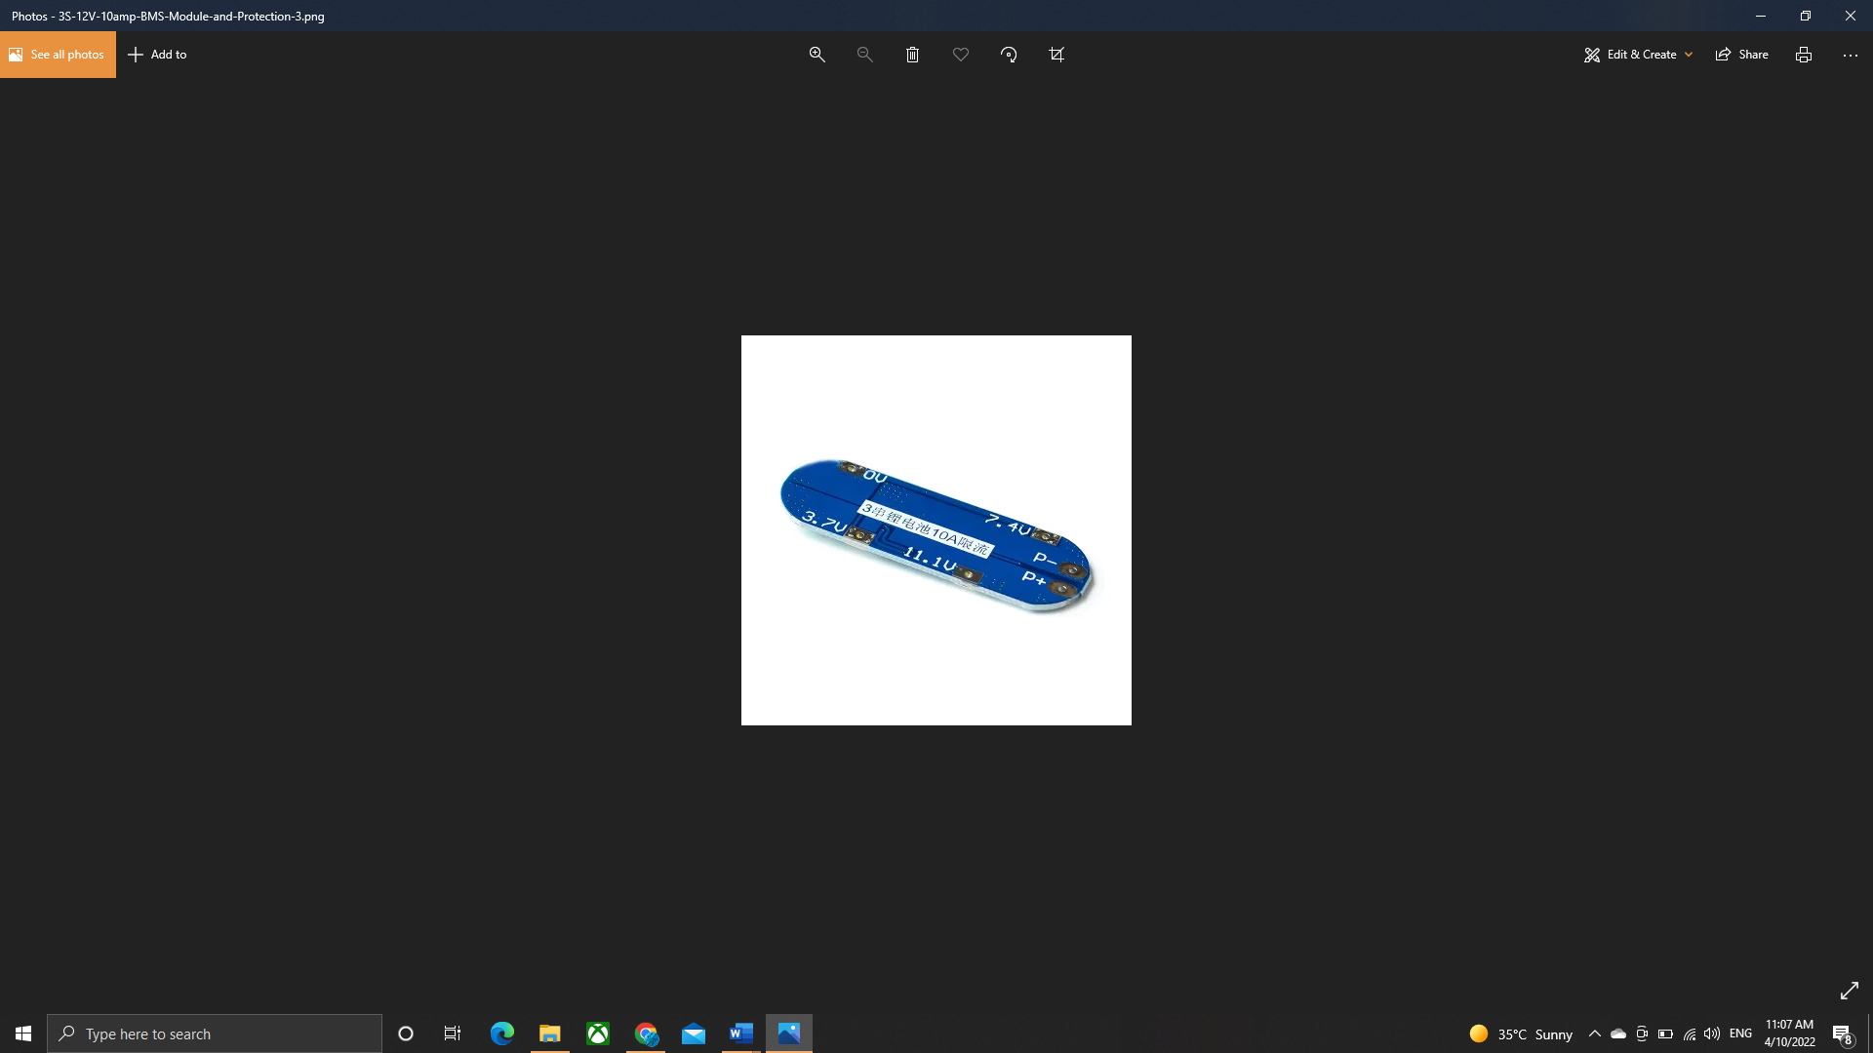

**Connection with BMS**

|  |  |
| --- | --- |
| P+ | Positive output from BMS |
| P- | Negative output from BMS |
| 0v | Negative side of first cell |
| 3.7v | Positive side of first cell and negative side of second cell |
| 7.4v | Positive side of second cell and negative side of third cell |
| 11.1v | Positive side of third cell |

The BMS acts like 3 separate modules for 3 separate cells and then these 3 modules are very smartly integrated together with transistors and passive components to make a complete BMS that is able to deliver current up to 10A and protect individual cell’s parameters.

**WORKING OF THE MODULE**

The BMS has 2 ICs, DW01, and BB3A; some variants of this BMS may have the same ICs or similar ICs from different manufacturers. But all the ICs will have the same pinouts and functioning. I will be discussing about DW01. The figure below shows the parts of BMS responsible for different operations.



Diode

Overvoltage, Over discharge, over current protection and short circuit protection

Responsible for disconnecting the BMS and Battery

From the above picture we see that right set of circuit which have IC named DW01 does the most of the work in BMS and is responsible for short circuit protection as well. And the left side set of circuit which have mosfets is responsible for the connecting or disconnecting the BMS from the source.

**DW01-A: Battery Protection IC**

DW01-A is a 1 cell Li-ion/ Polymer battery protection IC. It is responsible for all the protection features of the BMS. Each individual cell has 1 DW01-A connected which monitors the health of the particular cell. It comes in a 6 pins sot-23-6 package. You can refer to the IC’s datasheet to see the functional diagram and other data. It has an internal voltage divider circuit that is responsible for measuring the undervoltage and overvoltage of the cell. The short circuit and overcurrent are detected by the comparators which compare the voltage between CS pin input and VSS.

Electrical Characteristics of DW01-A

The working of any Integrated circuit depends on how it has been designed, which is given by the manufacturer, the electrical characteristics of DW01 is given in the table below:

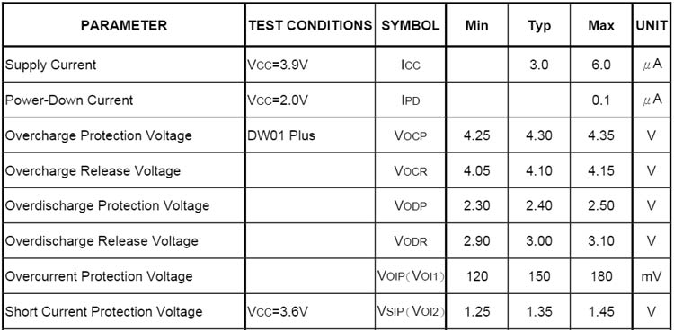

**Protection Circuit**

The protection circuit of this battery pack is shown here. Here, the Batt+ and S3 denote the positive and negative terminals of the cell respectively. The IC measures the voltage of the cell using an internal voltage divider circuit between VCC and ground pin and based on the electrical characteristics table shown above control the Over-discharge (OD) and Overcharge (OC) pin thus controlling the transistors Q18 and Q19 in the figure below.  
The DW01-A constantly monitors the overcurrent or short-circuit by measuring the voltage at the current sense pin. In the case of a short circuit the voltage exceeds VSIP, and the fault, i.e., the short circuit is inhibited by turning off the discharge control MOSFET.

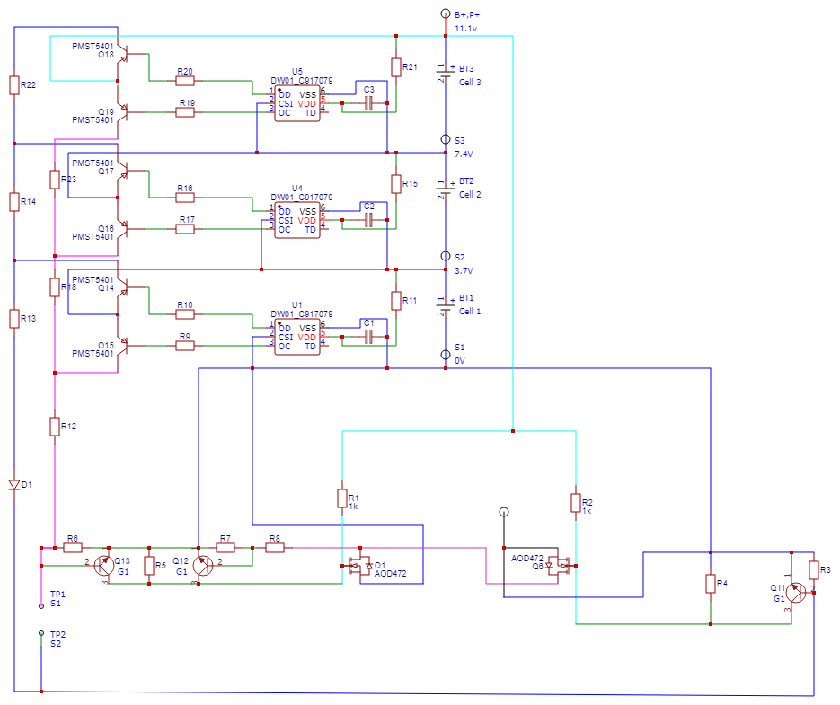

In the above figure, you can observe that the VDD pin is connected to the positive terminal of the cell with a resistor R21 and VSS and VDD have a capacitor C3 parallel to them. The capacitor and resistor are essential for suppressing the ripples and disturbance from the charger.

**Balance charging IC information HY2212 BB3A (addition info)**

Coming to the cell balancer circuit, the heart of this circuit is **HY2212 BB3A**, 1 cell Li-ion/polymer battery charger balance IC. This IC is capable of active balancing of a cell by electrical level monitoring and it comprises a very high-accuracy voltage detection circuit and delay circuit.

The series of HY2212 is created for a single-cell lithium-ion or can also be used for multi-cell battery packs with individual cells. It features **charge balance control**, **electrical level monitoring ICs** and it also comprises a **high-accuracy voltage detection** circuit and **delay circuit**The functional block diagram of the IC is given below, as you can see, the IC has a voltage divider circuit connected to the input VSS and VDD which is being fed to the overcharge detection comparator, which is used for controlling the enhancement MOSFET. You can refer to the datasheet of the IC to see the internal block diagram of this IC. It has a very simple circuit that just measures the voltage using a voltage detection comparator and gives an output. The output is used to control the gate of a MOSFET. Either P-type or N-type MOSFET can be used and the effective operation of both MOSFET are given in the table below.

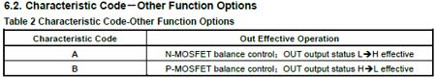

In this BMS an N-channel BMS is being used which is then connected to a Resistor of 480 ohm, the circuit used in the BMS is shown in the image below:

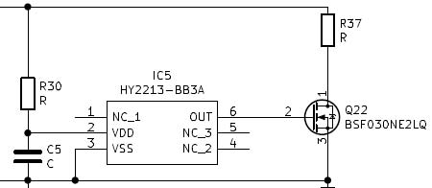

MOSFET

In the above circuit, the MOSFET used with this IC is A2SHB which is an N-channel Enhancement MOSFET. When the out pin from pin 6 of BB3A gives a high signal to the gate of this enhancement type MOSFET, the MOSFET connects a low resistance path through this 480-ohm resistance which acts as a load resistor and starts depleting the battery.

R37R is 480ohm resistor.

The rate of discharge can easily be found by **Ohm’s law. V=IR**

rate of discharge

 So, the battery can be discharged at a rate of 91 mill-Amp per hour. We can change the discharge rate by changing the value of the resistor.

**Full circuit diagram of 3s 10A BMS**



The above image shows the complete circuit diagram of the BMS circuit, as discussed above the circuit can be divided into smaller modules for monitoring every single cell.  
As shown in the image below, the Battery charging IC, DW01 is connected in parallel to the cell.

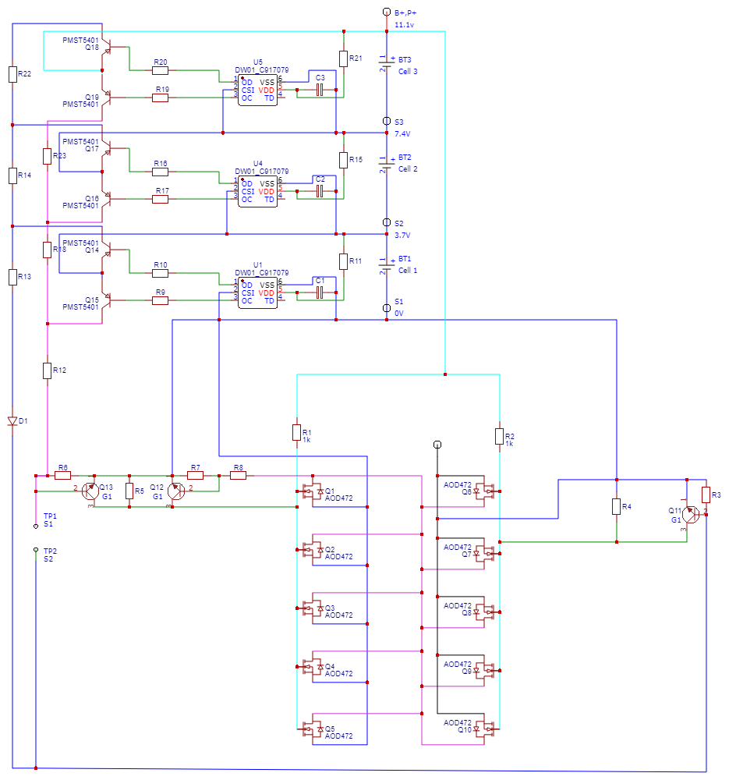

As explained above the VSS and VDD of DW01 are connected with the negative and positive of the cell respectively, and pin 2 which is the current sense pin is connected to the negative rail. According to the received input from the current sense pin, the Overcharge and Over-discharge transistors are controlled.

### ****How does the 3s 10A BMS Circuit work?****

The 2 MOSFET AOD472 are connected as 2 sets of 1 MOSFETs each.  The first set is for overcurrent protection and the other set is responsible for over-discharge protection. All cells in the circuits can trigger the overcurrent or over-discharge protection, this is required as the cell health degrades at different rates for different cells. The Gate of all the parallel MOSFETs is connected together and so is the source pins in order to trigger them together. All the 2 MOSFETs have their drain pins connected together, which means that the circuit will only work when the MOSFET is in the on state, else no current will flow and the Battery pack will neither power the output nor charge at that time.

**Controlling the MOSFETs**

The MOSFETs are controlled by controlling the overcharge and over discharge pins of the DW01 IC. The source on the left side MOSFET is connected to the ground, the current sense pin of DW01 is connected with the source, hence when there is a short circuit or an overcurrent is detected by the DW01 IC it turns on Q15 which turns on the transistor pair giving a signal to the gate terminal thus turning the MOSFET off.

The Gate of the right pair of MOSFET which are responsible for protecting the battery pack from overcharging is connected to the positive terminal of the battery pack. When the battery is overcharged, the DW01 IC will sense the overcharge condition using the internal potential divider circuit and will turn on the OD transistor.



Responsible for disconnecting the BMS and Battery

Taking the IC 1 (U5) in this condition, it will turn on transistor Q18, the flow of the current will turn on Q11 connecting the gate of the combination of parallel MOSFET responsible for overcharge protection with the ground thus turning it off and hence disconnecting the whole circuit. The below graph shows us the working of the DW01 IC during the charge condition.

**Components used in the 3S 10A BMS Module**

Coming to the components of the BMS, the BMS has 1 ICs, **DW01-A** which is a **battery protection IC**. Apart from the ICs, we have this component with text **G1** which is **MMBT5551** a **High voltage NPN transistor**, **2L** which is a **high voltage PNP transistor**,**PMST5401** apart from this we have a **Schottky rectifier** and here at the bottom we have 2 N-channel enhancement MOSFET **AOD472** which are connected in series which enables the high transfer of current and is a very crucial component for the overcurrent protection and overcharge protection.



DW01-A

**PMST5401**

**MMBT5551**

SS34

AOD473

**All the components used in the BMS are given in the table below:**

|  |  |
| --- | --- |
| DW01-A | Battery protection IC |
| G1 (MMBT5551) | SMD High Voltage Transistor (NPN) |
| 2L (PMST5401) | PNP high-voltage transistor |
| SS34 | Schottky rectifier |
| AOD472 | N-Channel Enhancement Mode Field Effect Transistor |

**Protection Features of 3S 10A BMS Module**

As discussed above, the BMS module has all the necessary features to protect the battery pack, it provides overcharge protection, over discharge protection, short circuit protection along cell balancing. More details about the protection features are given below.

**Overcharge Condition**

When the cell is charged beyond a safe charging voltage, the cell’s health is affected and the lifecycle of the cell is reduced. To protect the cell from overcharging, this BMS employs the overcharge protection mechanism which disconnects the battery pack from the charger. The working of the overcharge protection is shown in the graph below

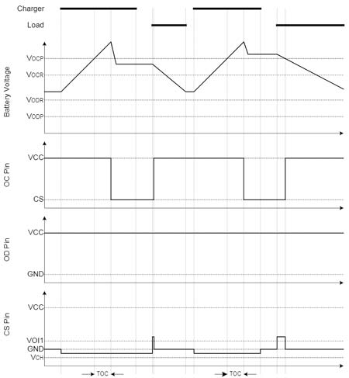

From the above graph, you can see that when the charger is connected, the battery voltage continues to increase, and as soon as it goes over Vocp (Overcharge protection voltage), it waits for the TOC (overcharge delay time) and opens the overcharge protection transistor thus switching off the overcharge protection MOSFETs. The IC won’t turn off the OC pin unless the cell’s voltage falls below the VOCR (Battery Overcharge release Voltage).

**Over Discharge Condition**

When the cell voltage goes below a safe operating voltage, the cell’s health is affected and the lifecycle of the cell is reduced. To protect the cell from over discharge, this BMS employs over discharge protection. The working of the over discharge protection is shown in the graph below-

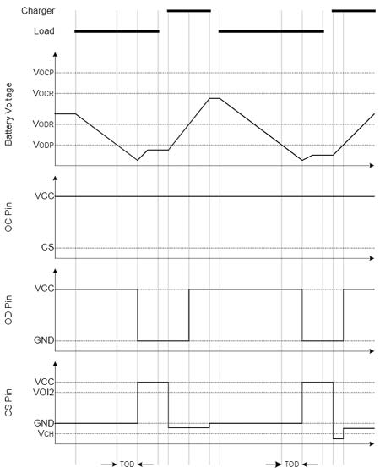

From the above graph, you can see that when the load is connected, the battery voltage continues to decrease and as soon as it goes under VODP (Over-discharge protection voltage) it waits for the TOD(over dis-charge delay time) and open the over discharge protection transistor thus switching off the over-discharge protection MOSFET. Hence no current flows through the BMS. And till the time the battery is not recharged and the voltage of the cell does not cross beyond the VODR(Over-discharge release voltage), the BMS doesn’t allow the usage of the battery pack, thus increasing the life of our battery pack.



The above image shows the flow of current during over discharge conditions. As you can see the transistors are connected in parallel because when the transistors are connected in parallel, they act as a single big transistor that can handle a higher amount of current.

**Transistors in parallel**

**Over Current Protection**

Over current protection in a BMS is necessary to safeguard the battery systems from overcurrent or short circuit when a short circuit fault occurs or there’s a surge in current from the load which is higher than the battery packs’ specification. This condition can affect the cell’s health or even cause damage to the cell leading to fires. To protect the cell from over current, this BMS employs overcurrent protection. The working of the overcurrent protection is shown in the graph below

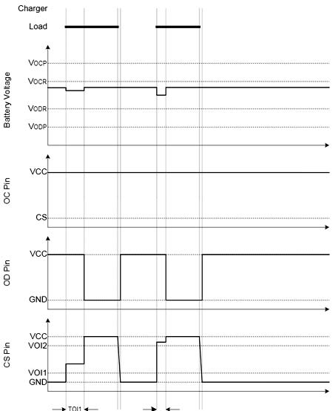

In normal conditions, the CS pin monitors the discharge current by constantly monitoring the voltage of CS pin. When there is a surge in current demand from the cell and the voltage in CS pin exceeds the VOIP(Over-current protection voltage) for longer than TOI1(Over-current delay time) the overcurrent protection circuit operates and turns off the OC MOSFET thus disconnecting the circuit. The overcurrent discharged protection is released only when the load is released or the impedance of the battery between the positive and negative terminal becomes greater than 500k ohm.

**Conclusion**

The 3s 10A BMS is an economical as well as very effective module to protect the Li-ion cells from getting damaged. The design can be modified to be used for a higher or lower number of cells making it a very versatile design. The components used in the BMS are readily available and a lot of replacement parts are available in the market making it a really good BMS to try for next projects.